Announcing the 16th Annual Event Saturday, September 16, 2023
from 6:00-10:00pm at “Center 615”

Featuring Wine and Beer Tasting by Midtown Wine & Spirits

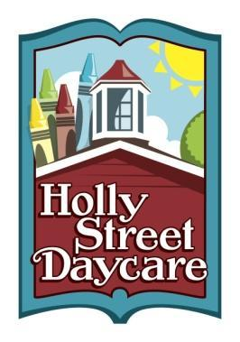
AUCTION DONOR FORM
Holly Street Daycare
Tax ID# 62-1439537
1401 Holly Street
Nashville, TN 37206
Phone (615) 227-8252
Fax (615) 227-9039 office@hollystreet.org

Donor Name to Appear on Printed Materials:
Item To Be Donated:
Details or Limitations:

For Event Tickets, Date of Event: _____________________________________
Gift Certificate: I will provide my own and mail it to Holly Street (please call 615-227-8252 for pick-up)
Please make one for me
1. Date of Expiration (if applicable, prefer min of one year from event):_____________
2. For Services, hours included: _________; Hourly Rate, if above hrs donated:________
Dollar Value of Item or Service Donated: ____________
Date Available for Pickup or Delivery (circle preference): _______________________
Marketing:
I will provide visuals for display and/or contact info for winner
Cards/brochures or menu of services (min of 2 please – one for table, one for winner envelope)
Logo’d Item – mug, t-shirt, other
Display requiring an easel – will label all items with contact info on back if they need to be returned
Donor Contact:
Business Name:
Address:
Phone: Email:
Website/Facebook:
